**ACTION PLAN**

**Issue 1 _**

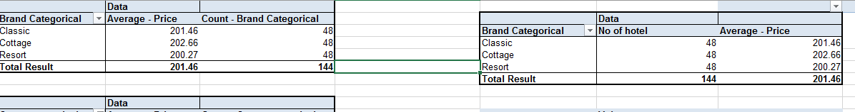

Average prices across brands across 144 hotels, we have cottage leading followed by classic then resort on average pricing

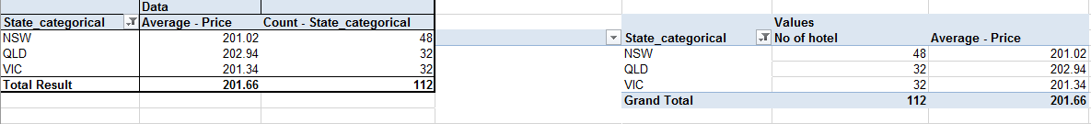

Average prices across states based on 112 hotels, with QLD having the highest prices then VIC finally NSW

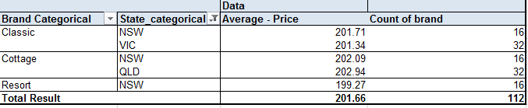

There are three brands: Classic, Cottage, and Resort. The states mentioned are New South Wales (NSW), Victoria (VIC), and Queensland (QLD). For the Classic brand, the average price in NSW is 201.71 and there are 16 units. In VIC, the average price is 201.34 with 32 units. For the Cottage brand, the average price in NSW is 202.09 with 16 units, and in QLD, the average price is 202.94 with 32 units. For the Resort brand, the average price in NSW is 199.27 with 16 units. The total average price across all brands and states is 201.66, and the total count of all units is 112

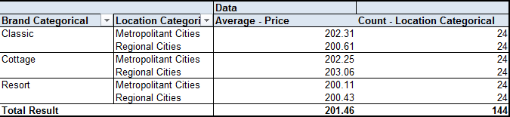

**Issue 2 _**

1. Let
   1. Null Hypothesis (H0) = μ_resort = μ_cottage = μ_classic
   2. Alternative Hypothesis (H1) = At least one of the means (μ_resort, μ_cottage, μ_classic) is significantly different from the others.
2. **α** = 0.05
3. **decision rule** 
   1. Reject H0 if p-value < 0.05.
   2. Fail to reject H0 if p-value ≥ 0.05.
4. **Organized data**

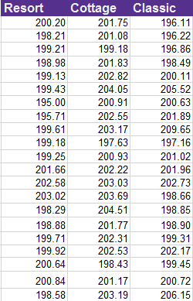

One-way Analysis of Variance (ANOVA) test. ANOVA is a statistical method used to test differences between two or more means.

1. **Results and decision**

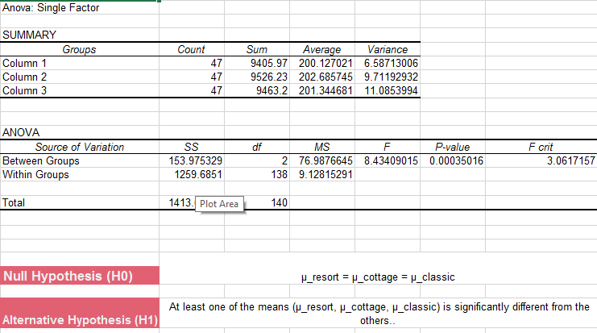

* 1. The P-value is 0.000350159, which is less than 0.05, indicating that the differences between some of the means are statistically significant.

1. **Conclusion**
   1. Based on the ANOVA results and the alpha value of 0.05, we reject the null hypothesis (H0) that the means of all accommodation brands are equal. Therefore, we conclude that there is a significant price differentiation among the Resort, Cottage, and Classic brands

**Issue 3 _**

1. Let
   1. Null Hypothesis (H0) = μ_Resort_NSW = μ_Cottage_NSW = μ_Classic_NSW = μ_Resort_QLD = μ_Cottage_QLD = μ_Classic_QLD = μ_Resort_VIC = μ_Cottage_VIC = μ_Classic_VIC
   2. Alternative Hypothesis (H1) = At least one of the means (μ_Resort, μ_Cottage, μ_Classic) is significantly different from the others across different states.
2. **α** = 0.05
3. **decision rule** 
   1. Reject H0 if p-value < 0.05.
   2. Fail to reject H0 if p-value ≥ 0.05
4. **Organized data**

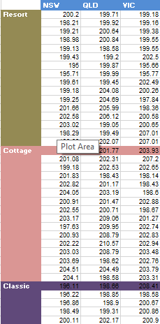

Two-way ANOVA test with replication, considering two factors: type of accommodation and location. The F-value and P-value are used to determine statistical significance. The results suggest a significant difference between the types of accommodation, but not between the locations or the interaction between type and location

1. 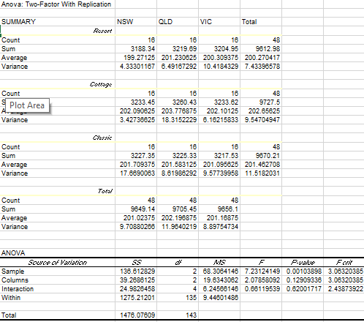
   1. The P-value: This is the probability that the differences observed could have occurred by chance. A P-value less than 0.05 is often used to indicate a statistically significant difference. In this case, the P-value for the sample is 0.001038978, for the columns is 0.129093359, and for the interaction is 0.620017165
   2. The F critical value: This is a value that our F-value is compared against to determine statistical significance. If the F-value is larger than the F critical value, we can reject the null hypothesis and conclude that there are significant differences between our groups. In this case, the F critical value for both the sample and columns is 3.063203853, and for the interaction is 2.438739218.
2. **Conclusion**
   1. From these values, we can conclude that there is a significant difference between the types of accommodation (since the P-value for the sample is less than 0.05), but not between the locations or the interaction between type and location (since the P-values for columns and interaction are greater than 0.05).

**Issue 4 _**

1. Let
   1. Null Hypothesis (H0) μ_Resort_Metropolitan = μ_Cottage_Metropolitan = μ_Classic_Metropolitan = μ_Resort_Regional = μ_Cottage_Regional = μ_Classic_Regional
   2. Alternative Hypothesis (H1) = At least one of the means (μ_Resort, μ_Cottage, μ_Classic) is significantly different from the others across different locations.
2. **α** = 0.05
3. **decision rule** 
   1. Reject H0 if p-value < 0.05.
   2. Fail to reject H0 if p-value ≥ 0.05
4. **Organized data**

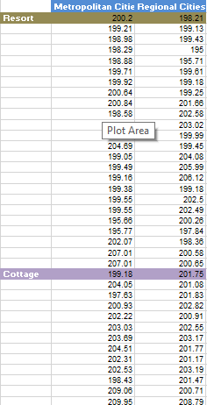

a two-way ANOVA test with replication, considering two factors: type of accommodation (Resort, Cottage, Classic) and location (Metropolitan Cities, Regional Cities)

1. 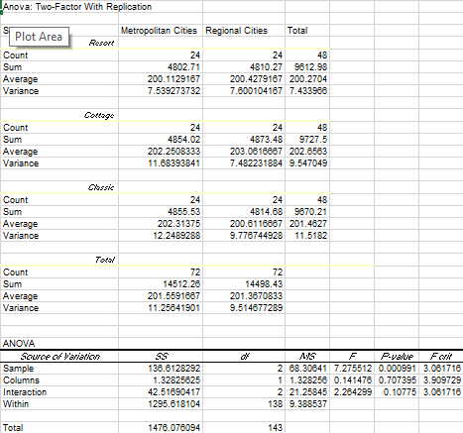
   1. two-way ANOVA test with replication, considering two factors: type of accommodation (Resort, Cottage, Classic) and location (Metropolitan Cities, Regional Cities). The ANOVA test results are used to determine if there are any significant differences between the means of the groups. The P-value for the sample is 0.000990862, which is less than the commonly used significance level of 0.05. This suggests that there is a statistically significant difference between the types of accommodation. However, the P-values for the columns (0.7073953) and interaction (0.107750223) are greater than 0.05, indicating that there is no significant difference between the locations or the interaction between type and location. Therefore, the type of accommodation has a significant effect on the results, while the location and the interaction between type and location do not.
2. **Conclusion**
   1. From the provided ANOVA test results, the conclusion that can be drawn is that the type of accommodation (Resort, Cottage, and Classic) has a significant effect on the results, while the location (Metropolitan Cities, Regional Cities) and the interaction between type and location do not. This is determined by the P-values obtained from the test. The P-value for the sample is less than 0.05, indicating a significant difference between the types of accommodation. However, the P-values for the columns and interaction are greater than 0.05, indicating no significant difference between the locations or the interaction between type and location.

**Issue 5 _**

1. Let
   1. H0 = μ_resort_with_comfort = μ_resort_without_comfort
   2. H1 = μ_resort_with_comfort ≠ μ_resort_without_comfort
2. **α** = 0.05
3. **decision rule** 
   1. Reject H0 if p-value < 0.05.
   2. Fail to reject H0 if p-value ≥ 0.05
4. **Organized data**

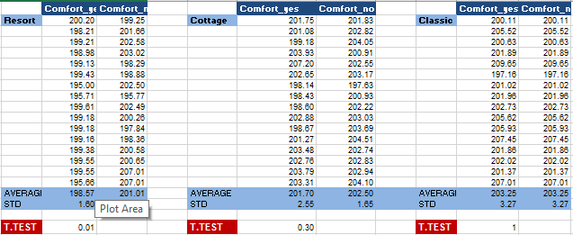

T-test, which is a statistical hypothesis test used to determine whether there is a significant difference between the means of two groups. In this case, the two groups are 'Comfort_yes' and 'Comfort_no' for three types of accommodation: Resort, Cottage, and Classic.

1. 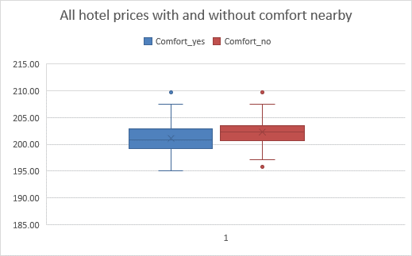

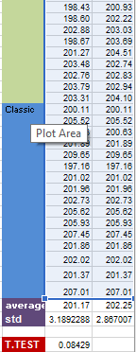

* 1. T-test was used in conjunction with some of the box and whisker to check for any competition and at first glance you could tell areas with no comfort nearby were generally more expensive and areas with comfort nearby were cheaper.
  2. The T.TEST value: This is the result of the t-test. It represents the probability that the differences observed could have occurred by chance. A T.TEST value less than 0.05 is often used to indicate a statistically significant difference. In this case, the T.TEST values for Resort, Cottage, and Classic are 0.01, 0.30, and 1 respectively

1. **Conclusion**
   1. Based on the provided t-test results, the conclusion that can be drawn is that there is no significant difference in comfort scores between 'Comfort_yes' and 'Comfort_no' for the Resort, Cottage, and Classic categories. This is determined by the T.TEST value of 0.084289994, which is greater than the commonly used significance level of 0.05. Therefore, we fail to reject the null hypothesis, suggesting that there is no significant difference in comfort scores between 'Comfort_yes' and 'Comfort_no' for these categories